Describe the images and guess.
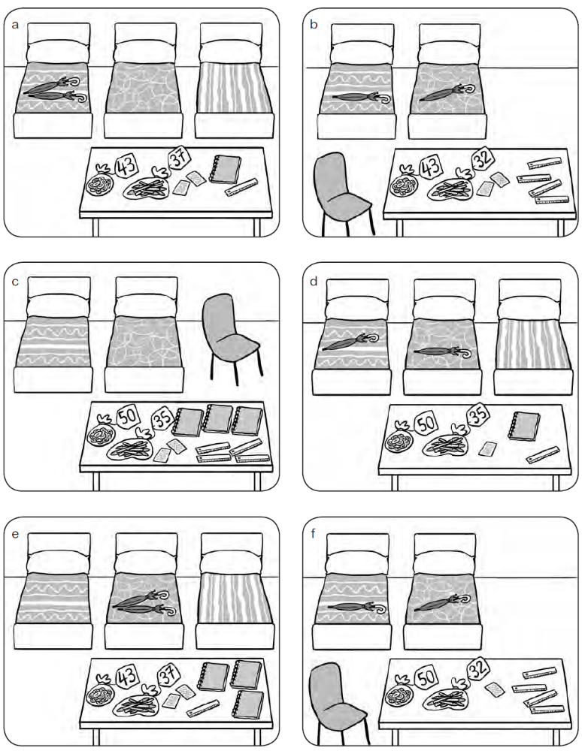

Let’s make a tipi!
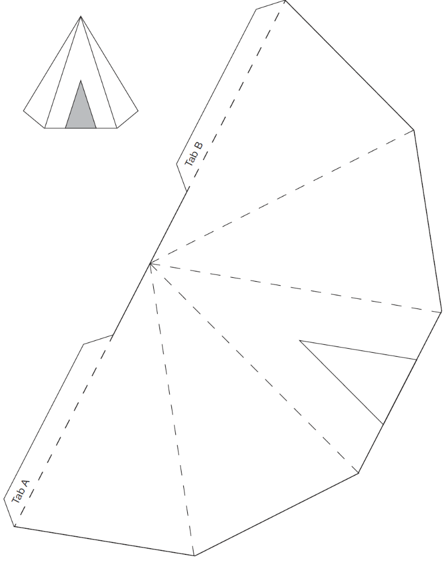
- Write the name of each object.
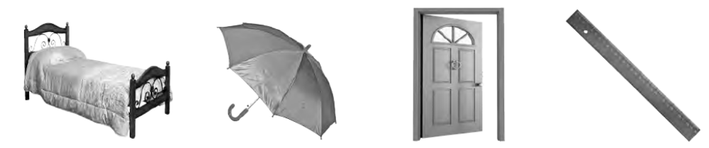
ed
1 b 2 u 3 d 4 r
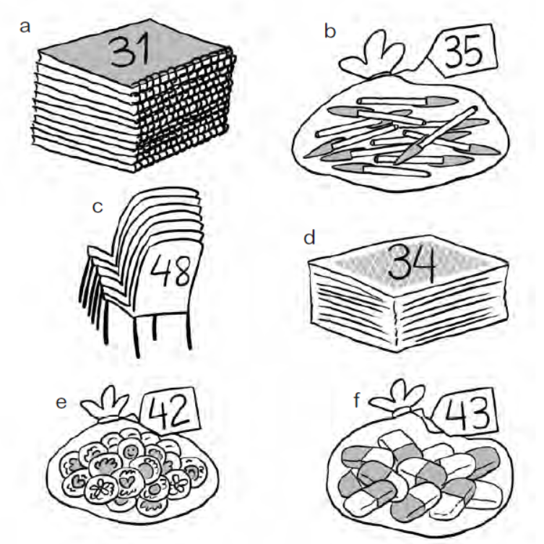
- Match the words to the images
1 forty-two stickers
2 forty-eight chairs
3 thirty-one notebooks
4 thirty-four cards
5 thirty-five pens
6 forty-three rubbers
- Circle the words that correspond to the objects in the picture.
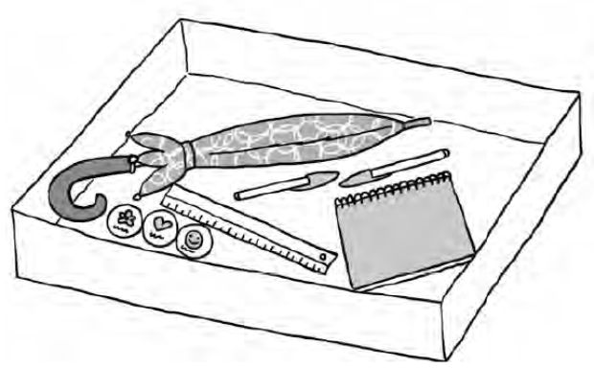
1 some stickers
2 a ruler
3 a notebook
4 some cards
5 some pens
6 an umbrella
- Write the name and number of each object.
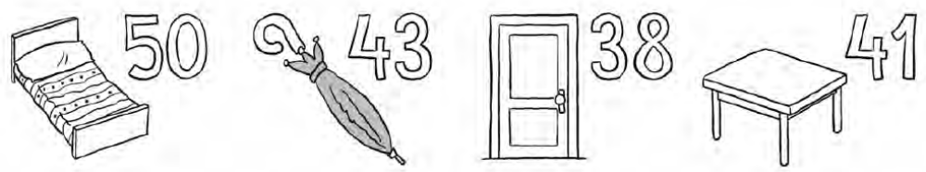
1 2 3 4
fifty beds

- Complete the sentences.
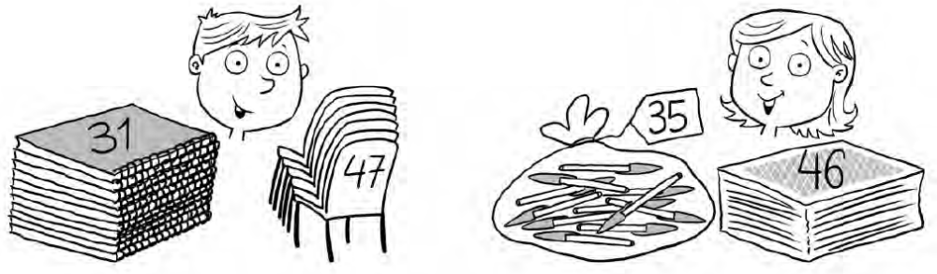
1 I’ve got 2 Rachel’s
thirty-one notebooks

- Write what objects you can see in the picture.
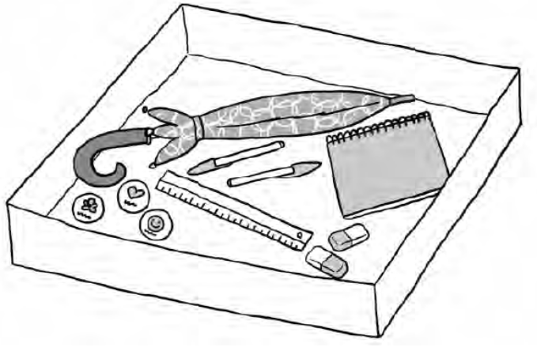
1
some stickers
a ruler
2
3
4
5
6
- Pre-listening activity: Point at the pictures and repeat.
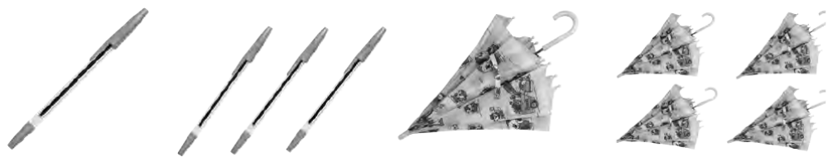
1 a pen 2 some pens 3 an umbrella 4 some umbrellas
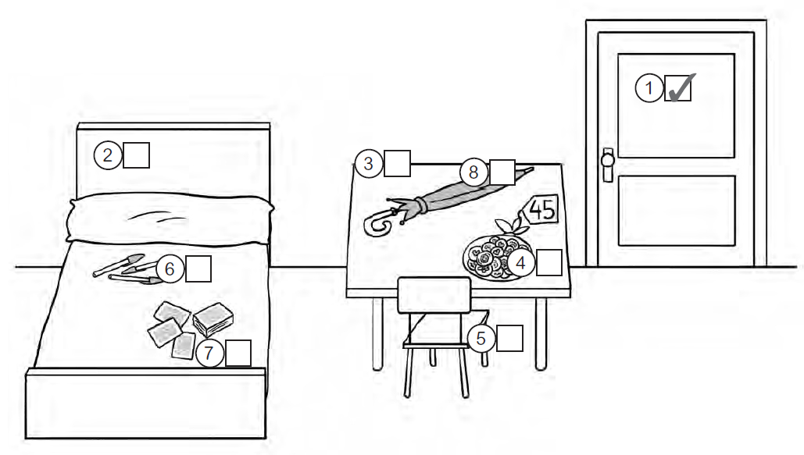
- Listen and tick (✓) the things in the room.

- Listen and choose true or false. Correct the false sentences.
1 There are two beds in Victor’s 4 There aren’t any chairs.
T F F
T F F
bedroom.

2 There are two blue umbrellas. 5 There’s a notebook.
T F F
T F F

3 There’s a big table. 6 There are some stickers.
T F F
T F F

Ask your classmates.Then give a presentation.

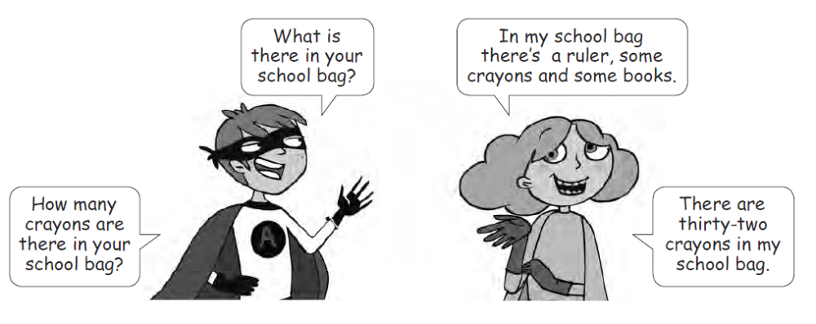

 | Name | Name
What is there in your school bag?
How many
are there in your school bag?
How many
are there in your school bag?
How many
are there in your school bag?

- Read the email.
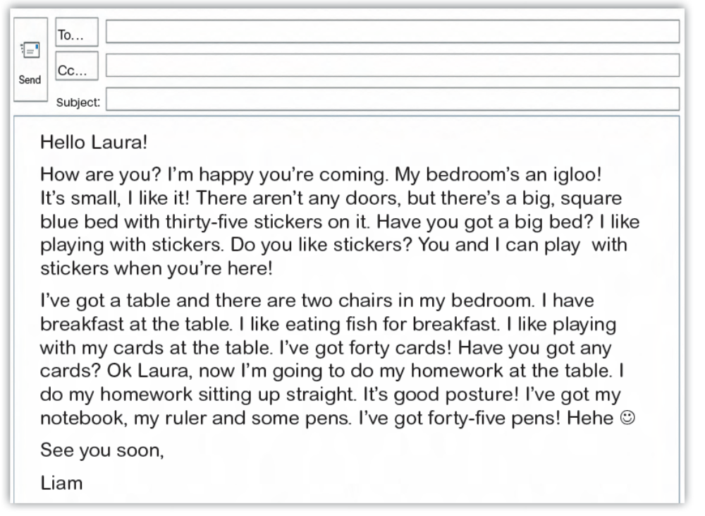
- Read the email again and complete.
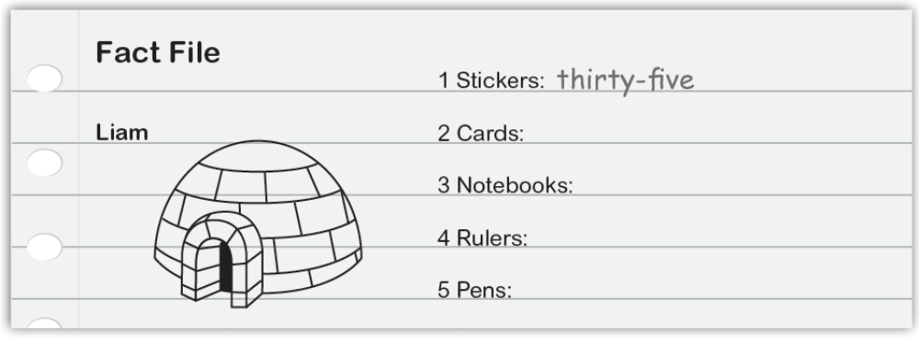
- Read the email again and circle the correct answer.
1 Liam's got an igloo / a tipi bedroom.
2 He's got / He hasn't got a small bed.
3 There are some tables / is one table in the igloo.
4 There are two / three chairs.
5 He's got good / bad posture at the table.
- Read the email.
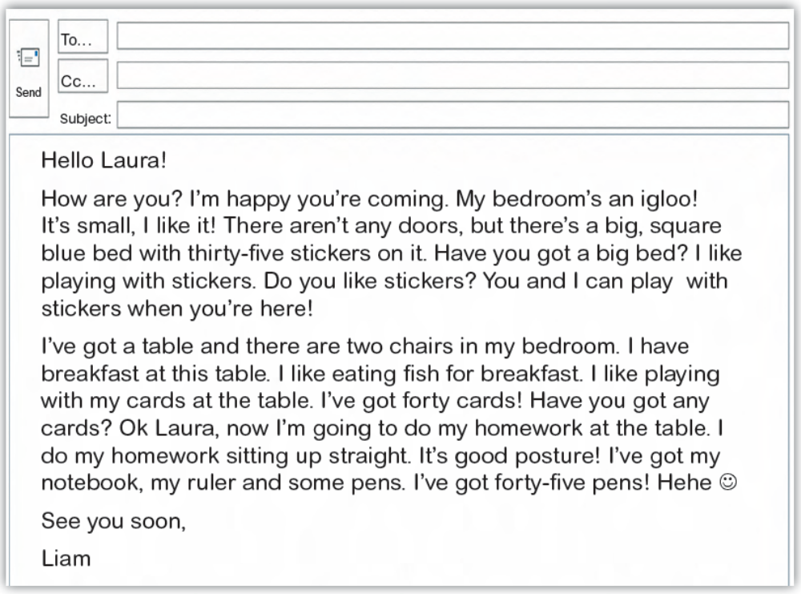
- Read the email again and complete.
- Read the email again and circle the correct answer.
He’s got an igloo bedroom.
1 What type of bedroom has Liam got?
2 Has Liam got a small bed?
3 How many tables are there in the igloo?
4 How many chairs are there in the igloo?
5 Has Liam got good posture on the table?
- Look and complete the sentences.
is
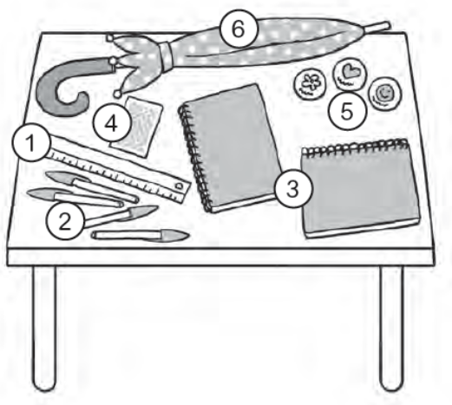
1 There a ruler.
2 There pens.
3 There notebooks.
4 There card.
5 There stickers.
6 There umbrella.
- Look and choose the correct option.
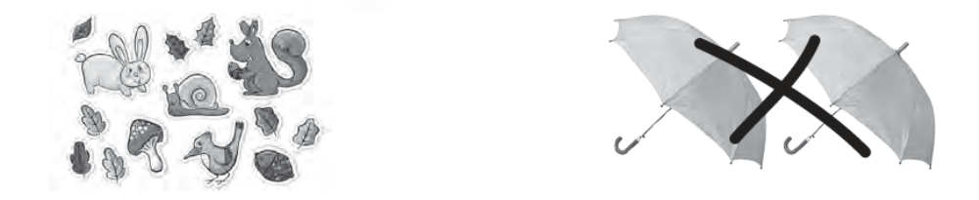
1 There are some / aren’t any stickers. 3 There are some / aren't any umbrellas.
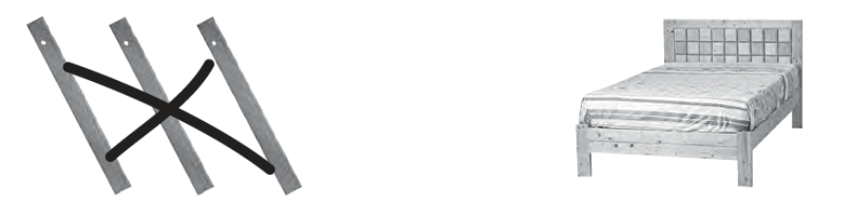
2 There are some / aren't any rulers. 4 There is / isn’t a bed.

- Write about Anne.
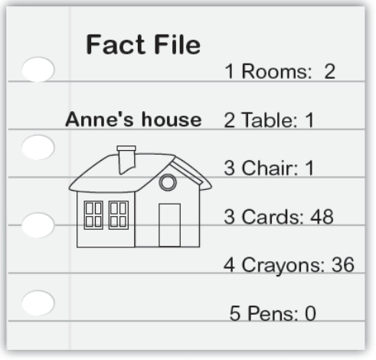
I live in a ______. My _______ has got ___
house
rooms. In my room there’s a _______ and a
__________. There are _______________
and __________________________. There
aren’t any ________. Do you like my room?
- Look and complete the sentences.
is
1 There a ruler.
2 There pens.
3 There notebooks.
4 There card.
5 There stickers.
6 There umbrella.
- Look and choose the correct option.
There are some stickers.
1 3
2 4

- Write about Anne.
I live in a ______. My _______ has got ___
house
rooms. In my room there’s a _______ and a
__________. There are _______________
and __________________________. There
aren’t any ________. Do you like my room?

