Colour and match up the images with the sentences.
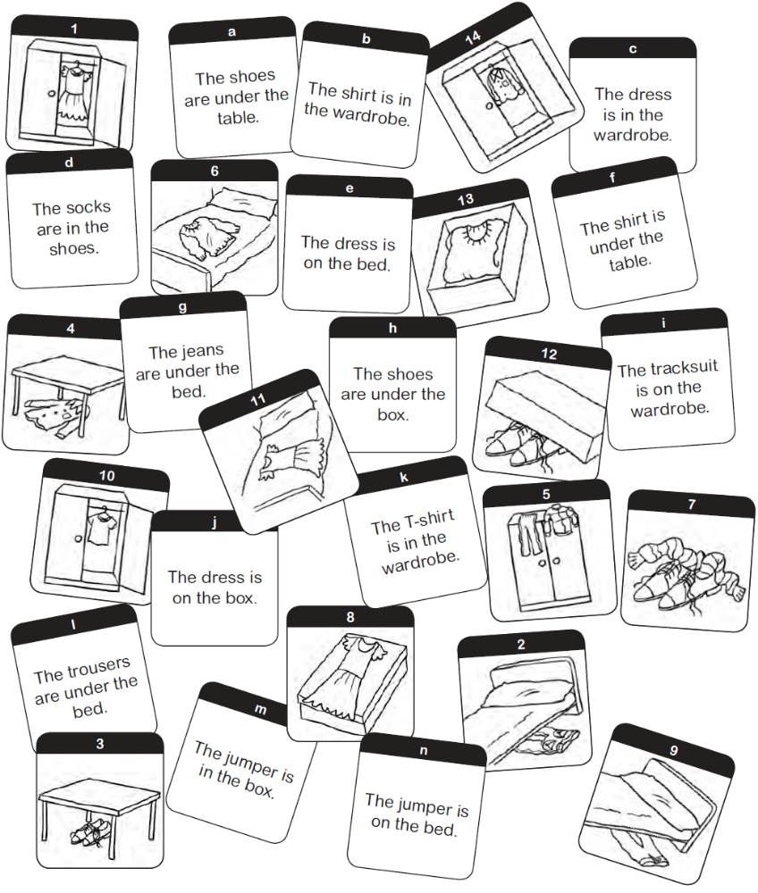

COLOUR INSTRUCTIONS: 1 Colour the dresses black and white. 2 Colour the jeans blue. 3 Colour the jumpers yellow. 4 Colour the shirts red. 5 Colour the shoes blue and white. 6 Colour the socks purple. 7 Colour the tracksuits red and blue. 8 Colour the trousers brown. 9 Colour the T-shirts pink.
What we wear!
In groups, think of typical clothes you wear at different times of the year in your community nd draw them. Present your drawings to the class.

At Easter: At Christmas:

At school: On the…………..

- Unscramble the words.
T - s h i r t
1 hstrti- _ _ _ _ _ _ _ 3 perumj j _ _ _ e _
2 okcss _ o _ _ s 4 enjas _ e _ _ _

- Look and complete.
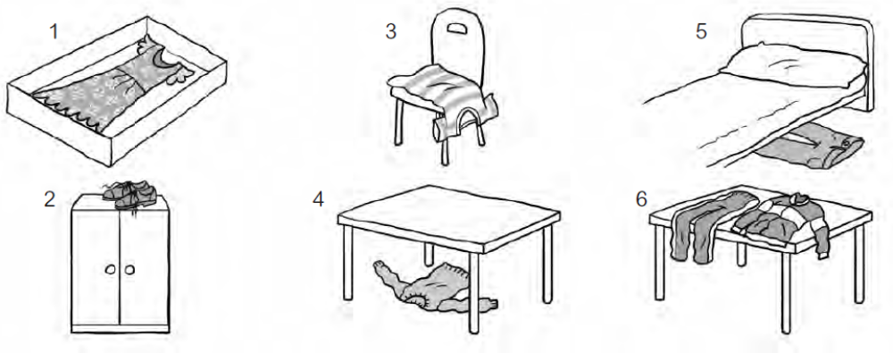
dress
1 The is in the box. 4 The is under the table.
2 The are on the wardrobe. 5 The are under the bed.
3 The is on the chair. 6 The is on the table.

- Look and complete.
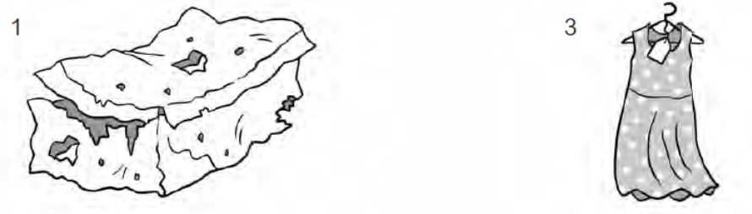
l
x
o _ d b o _ _ ew d _ es _
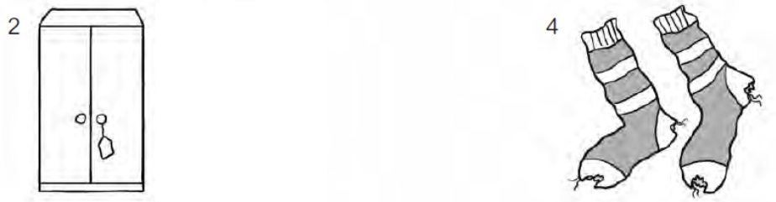
n _ w w _ rd _ _ b _ o _ l s _ c _ _
- Unscramble the words.
T - s h i r t
1 hstrti- _ _ _ _ _ _ _ 3 perumj _ _ _ _ _ _
2 okcss _ _ _ _ _ 4 enjas _ _ _ _ _

- Look and complete.
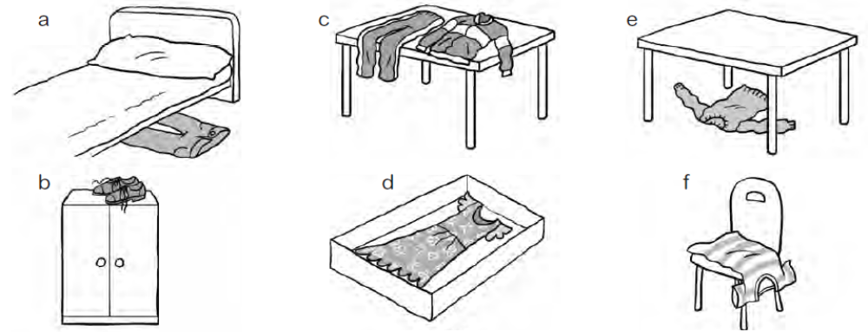
dress
1 The is in the box. 4 The is under the table.
2 The are on the wardrobe. 5 The are under the bed.
3 The is on the chair. 6 The is on the table.

- Look and complete.
old box
1 3
2 4
- Pre-listening activity: Find the odd one out.
socks skirt trousers wardrobe jumper
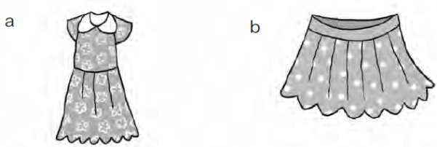
- Listen and match the sentence to the image.
1 Beth: I’m wearing a…

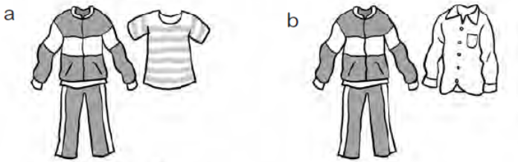
2 Tom: I’m wearing a…

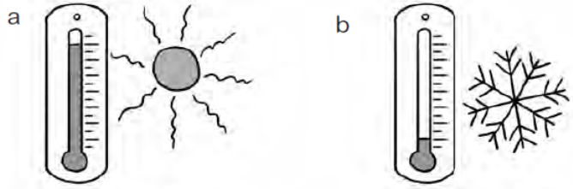
3 Tom: It’s…

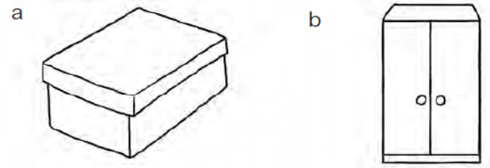
4 Beth: My jumper’s in my…

- Listen again and circle the correct answer.
1 Tom: I’m wearing an old / a new tracksuit.
2 Beth: It’s my mum’s / sister’s jumper.
3 Beth’s jeans are / aren’t in the box.
4 Beth’s jumper and jeans are in / on the bed.
5 Tom: Take off / Put on your jeans.
Ask and answer in pairs.
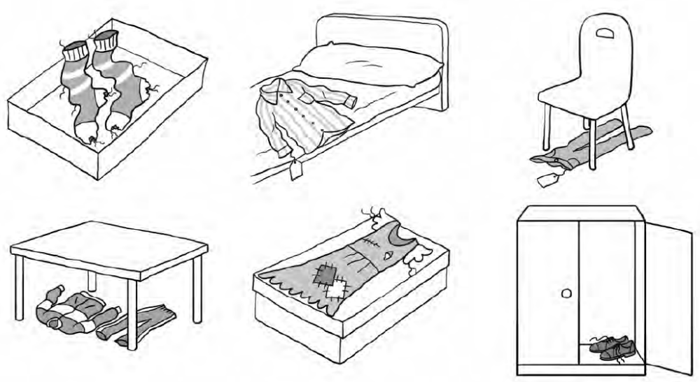
Where is / are…? They’re in/on/under…

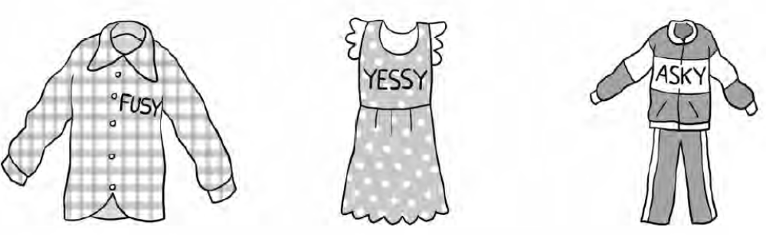
Is this your…? No, it’s Fusy’s…

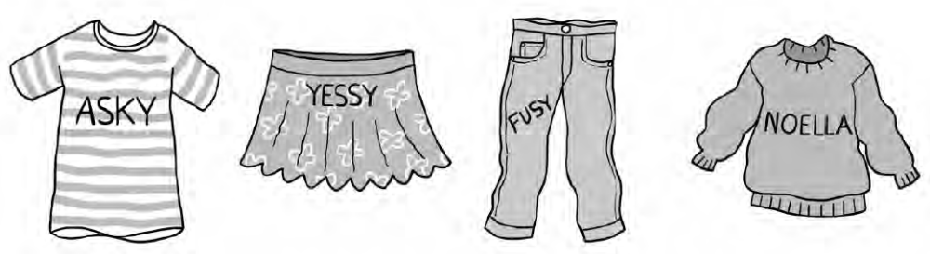
Is this Asky’s T-shirt? Yes, it’s his….
- Read the text again and answer true or false. Correct the false sentences.
- Read the text.
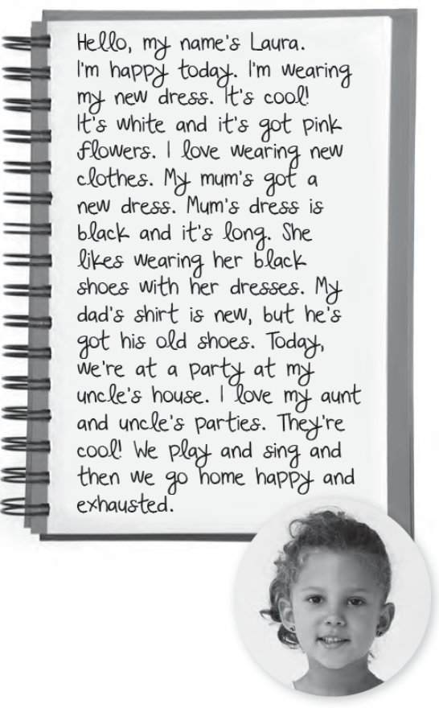
1 I’m not happy today.
I’m happy today.
False

2 I’m wearing an old white dress.

3 My mum’s dress is new.

4 My dad’s got his new shirt.

5 The party is at my grandad’s house.

6 I don’t like my uncle’s parties.

- Read the text again and draw Laura's and her family’s clothes.

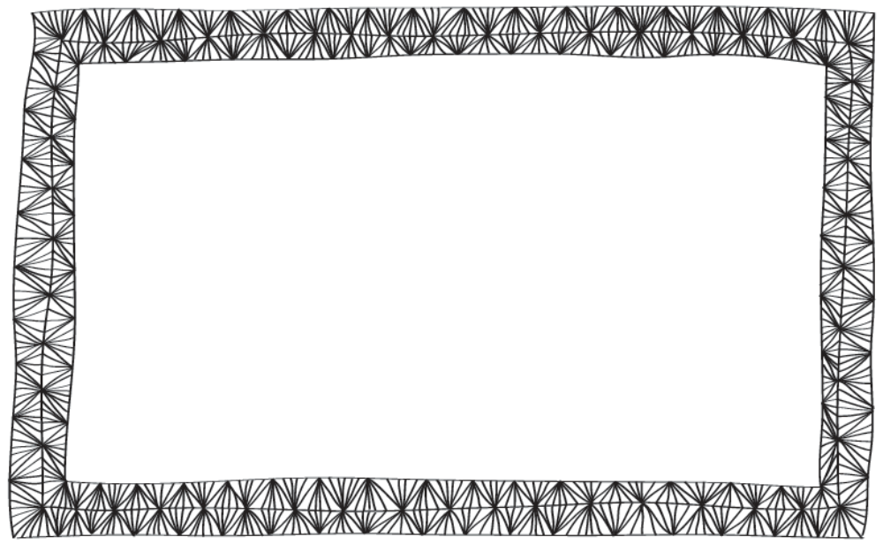
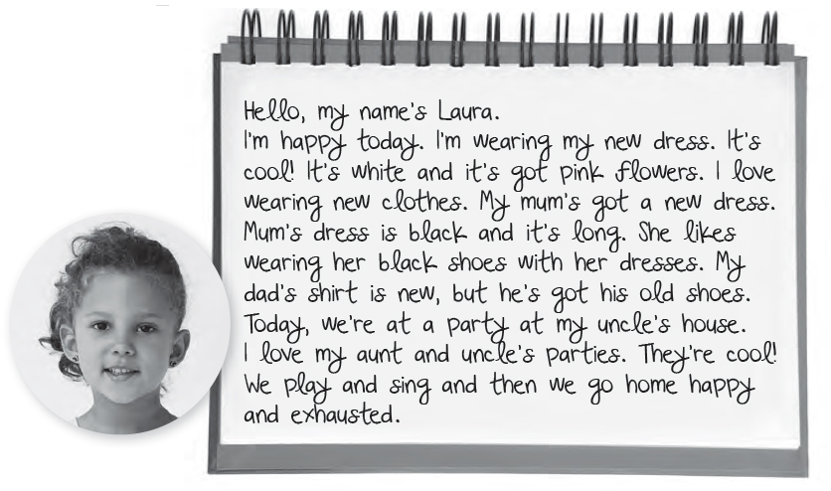
- Read the text.

- Read the text again and answer.
She's wearing her new dress.
1 What is Beth wearing?
2 What colour is her dress?
3 Is her mum’s dress new?
4 Is her dad’s shirt old?
5 Where’s the party?
- Read the text again and draw Laura's and her family’s clothes.
- Complete the dialogue.

Hello, Fusy. Is that (1)
Asky’stracksuit?
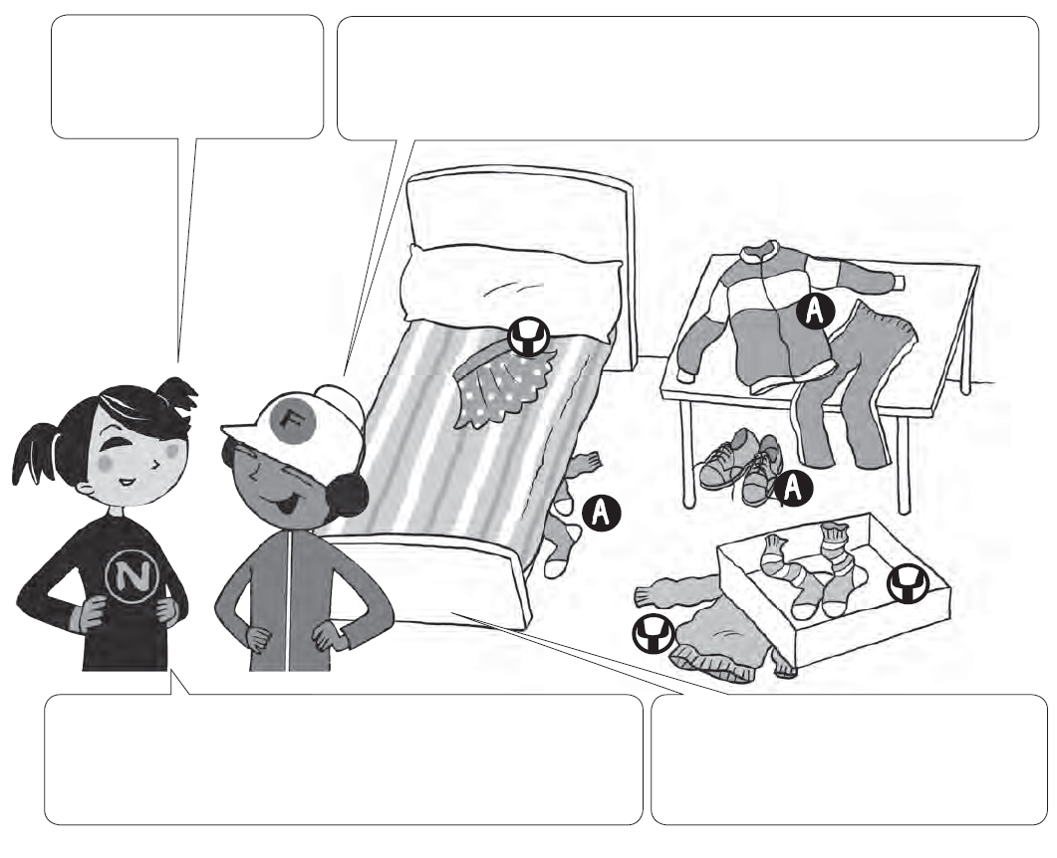
Yes, it’s his tracksuit. (2) H ________ shoes are (3) _______
the table. (4) H _________ socks are under the bed.
Those are Yessy's socks. They’re (5) ________
the box. Where’s (6) ___________ jumper?
It’s under the box. And that’s (7)
________ skirt. It’s on the bed.
- Write a similar dialogue.
Yessy: Hello, ___________ . Is that Fusy’s __________________________ ?
Asky: Yes, it ______________. ____________ shoes are ______________.
______________ _______________ are under _________________.
Yessy: Those are Noella’s ________ . They’re ____________ the ________.
Where’s ________________________________________________?
Asky: It’s ______________. And that’s ____________. It’s _____________.
- Complete the dialogue.

Hello, Fusy. Is that (1)
Asky’stracksuit?
Yes, it’s his tracksuit. (2) H ________ shoes are (3) _______
the table. (4) H _________ socks are under the bed.
Those are Yessy's socks. They’re (5) ________
the box. Where’s (6) ___________ jumper?
It’s under the box. And that’s (7)
________ skirt. It’s on the bed.
- Write a similar dialogue.
Yessy: Hello, ___________ . Is that Fusy’s __________________________ ?
Asky: _____________________________. His ______________________.
_______________________________________________________.
Yessy: Those are Noella’s _________________ . _____________________.
_______________________________________________________?
Asky: It’s ______________. And that’s ____________. ________________.

