Read and colour.
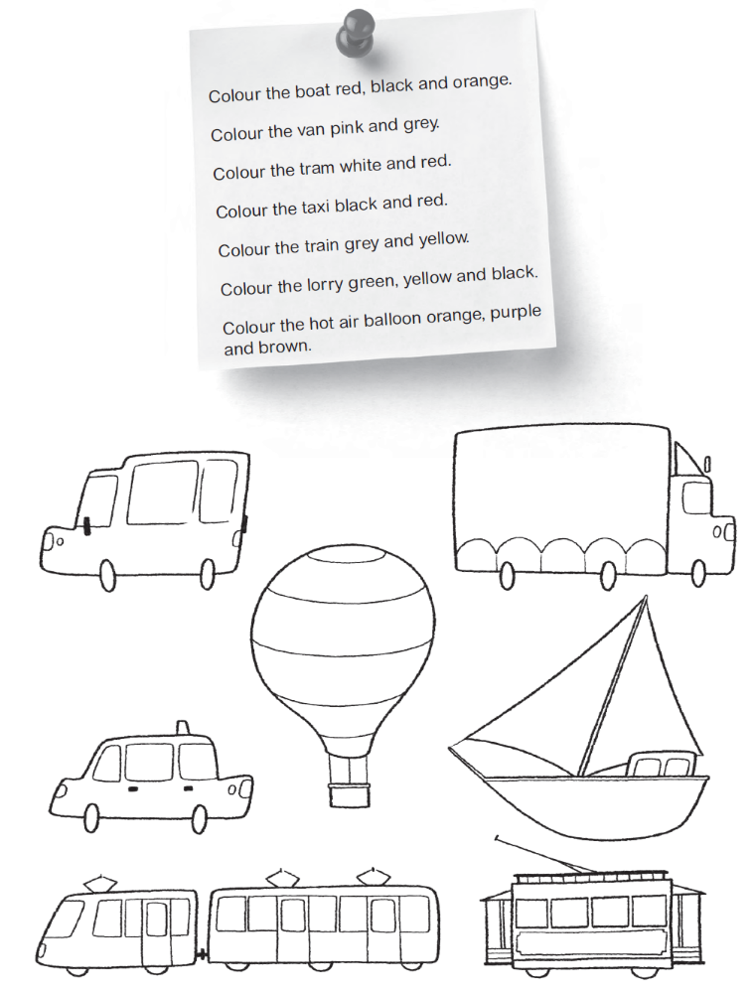
Colour and play.

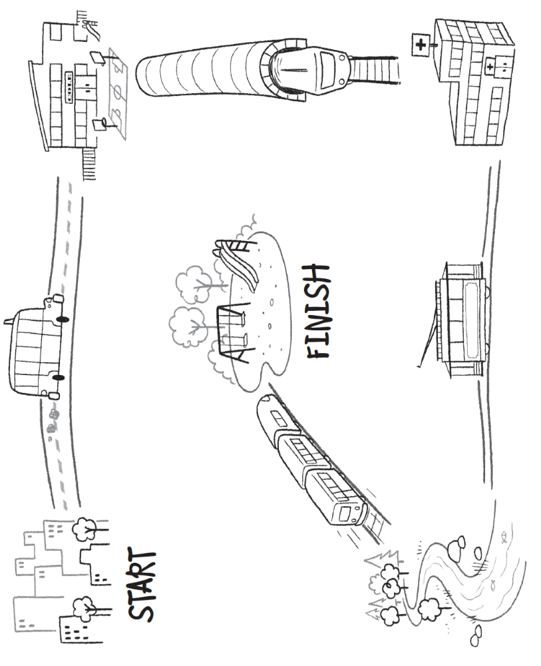
- Match the pictures to the words.
helicopter
tram
hot air boat
balloon
lorry
bus
ship
taxi
boat
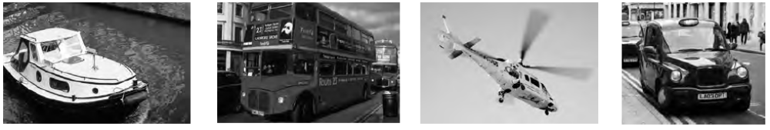
boat
1 ______________ 3 ______________ 5 _____________ 7 __________
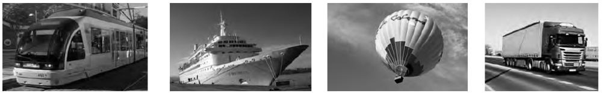
2 ______________ 4 ______________ 6 _____________ 8 __________
- Find the words. Then draw the type of transport.
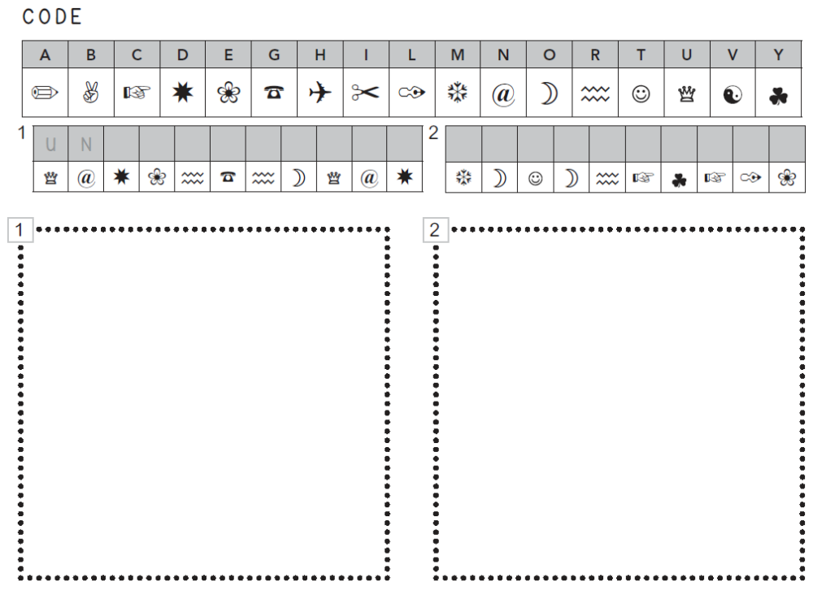
- Write the words.
b o a t
1 _ _ _ _ 3 _ _ _ 5 _ _ _ _ _ _ _ _ _ _ 7 _ _ _ _
2 _ _ _ _ 4 _ _ _ _ 6 _ _ _ _ _ _ 8 _ _ _ _ _
_ _ _ _ _ _ _

- Find the words.
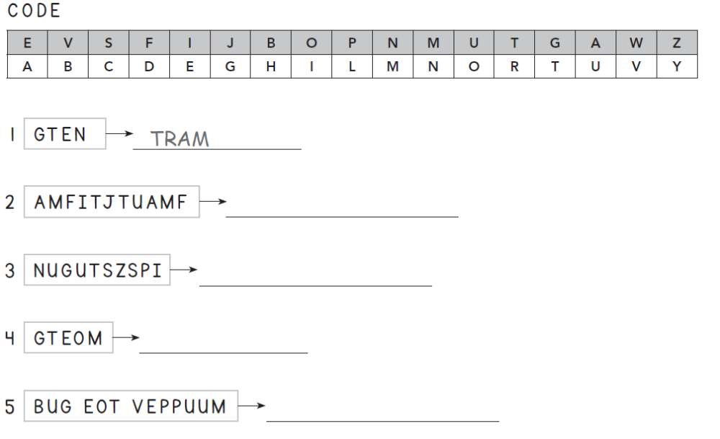

- Pre-listening Activity: Ask your friends.
How do you go…? | Name: | Name:
to school
to the river
to the mountain
to the park

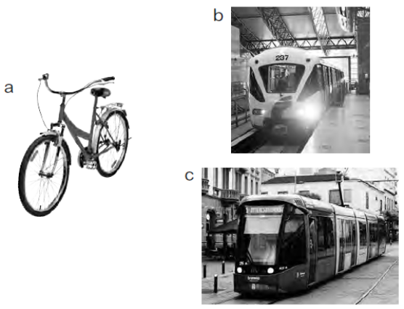
- Listen. Match the pictures to the names.

Emilia

Jennifer

Robert

- Listen again and complete the sentences.

Emilia
I live (1) _______________with my family. I’m (2) ________ _years old and my
brother is six years old.

Jennifer
I’m (3) __________ years old. I like going to school by (4) _________ : it’s fast.

Robert
Hi! My name is Robert. I’m seven years old. I go to (5) ________ by bicycle.
I like riding my (6) ______________ !
- Invent a new form of transport. Draw it in this box.
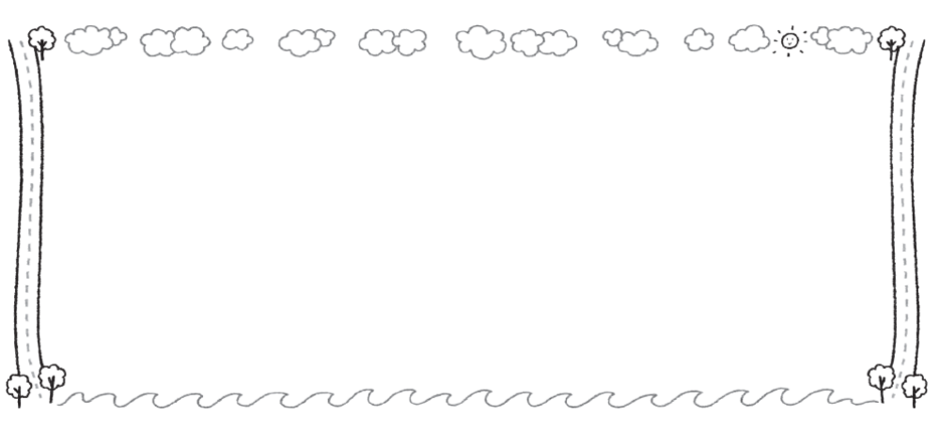
- Answer the questions about your invention.
• What colour is it?
• Can it fly?
• Is it fast or is it slow?
• Can it go under water?
• What can it do?
• How much is a ticket?
- Present your invention to the class.

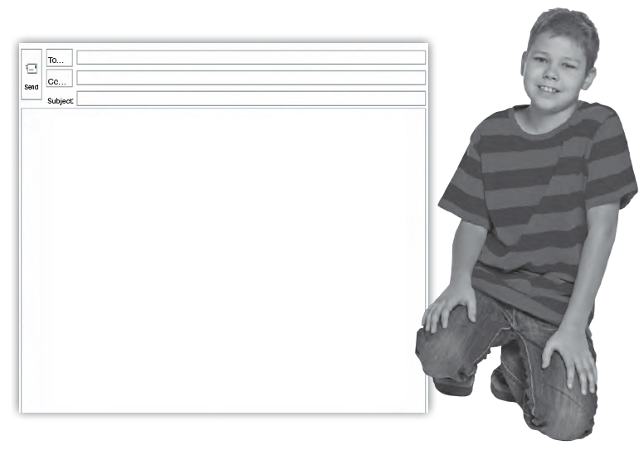
- Read the text.

Hello! My name's Simon. I'm 9 years old. I've got a sister and a brother. My sister's name is Layla and my brother's name is Freddie. I go to school by car. My mum has got a black car and my dad has got a big green car.
On Fridays, I go to school by taxi! I love Fridays! On Saturdays, I walk to the park and play with my brother and sister and on Sundays, I go to the river by train with my grandma.

- Read the text again and draw.
1 I go to school... 3 I go to the river...
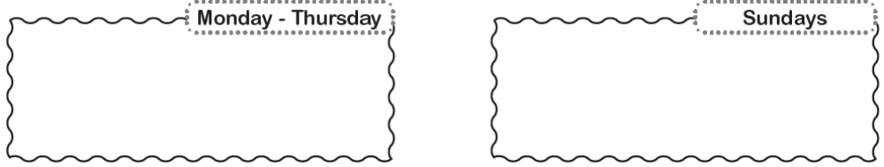
2 I go to the park... 4 I go to school by taxi.
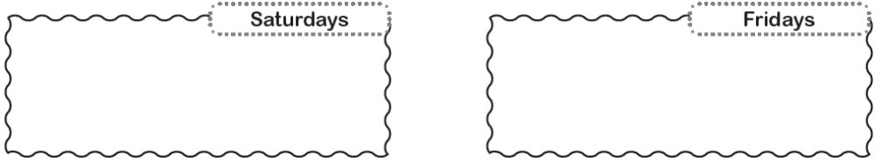
- Read the text again and complete the sentences.
car.
1 On Tuesdays I go to school by
2 On Fridays I go to school by .
3 On Saturdays I to the park.
4 On Sundays I go to the river by
- Unscramble the words and complete the text.
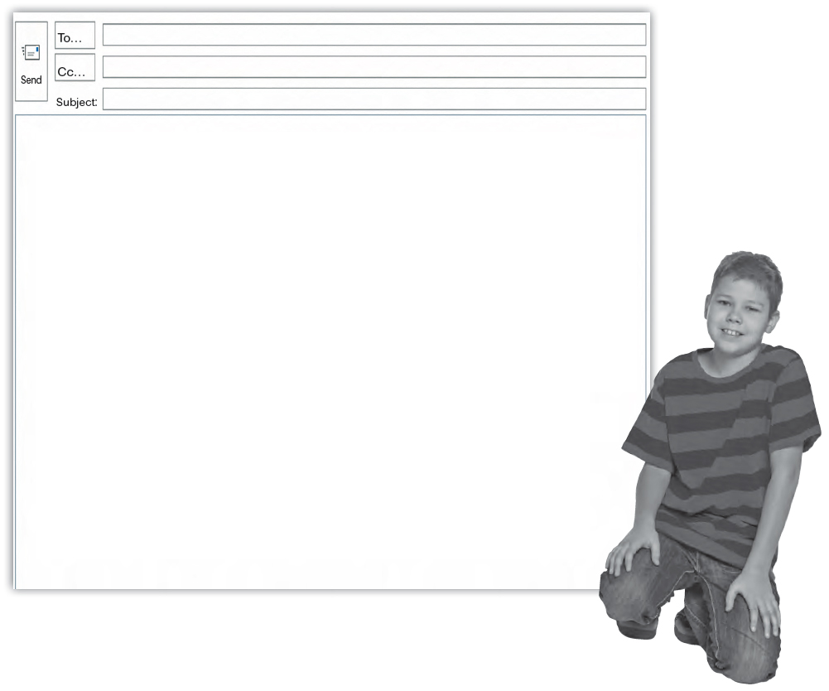

Hello! My name’s Simon. I’m 9 years old. I’ve got a
brother
sister and a (1) __________ (errobht). My sister’s name
is Layla and my brother’s name is Freddie. I go to school
by (2) __________ (rca).
My mum has got a black car and my dad has got a big
green car. On Fridays, I go to school by (3) __________
(xati) ! I love Fridays! On Saturdays, I walk to the (4)
__________ (kpra) and play with my brother and sister
and on Sundays, I go to the (5) __________ (virre) by
(6) __________ (itrna) with my grandma.

- Read the text again and complete the table.
Where? | When? | How?
to school | Monday - Thursday
to school |  | by taxi
 |  | walk
to the river

- Look at the pictures and write.
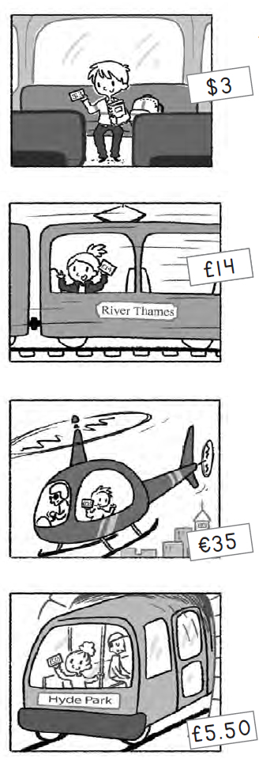
1 How do you go to school?
I go to school by bus.
How much is a ticket?
It’s three dollars.

2 How do you go to the river?
the river by train
I go to .
How much is a ticket?
It’s

3 How do you go to the city?
.
How much is a ticket?
.

4 How do you go to the park?
.
.
.
- Write about yourself.
1 How do you go to school?

2 How do you go to the park?

3 What’s your favourite type of transport?

- Look at the pictures, match and complete.
1 How do you go to school?
to school by bus.
I go .
How much is a ticket?
It’s three dollars.

2 How do you go to the river?
I go to .
.
It's fourteen pounds.

3 How do you go to ?
.
How much is a ticket?
.

4 How do you go to the park?
.
.
.

- Write about yourself.
I go to

