Use these words to create a wordsearch.
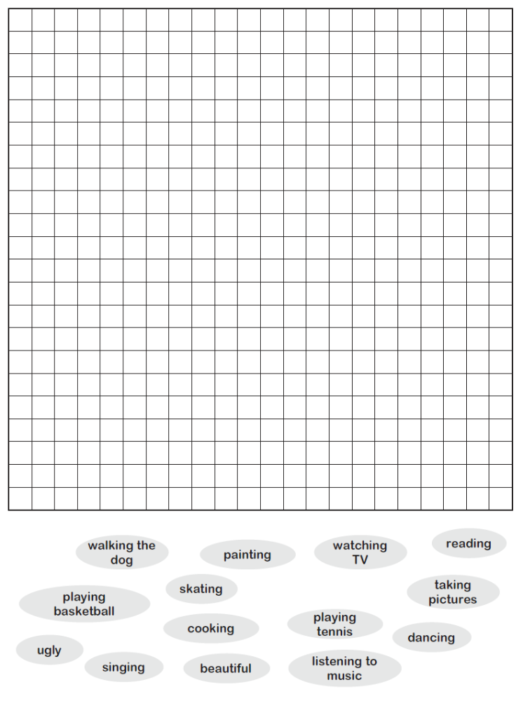
Let’s play Top Trumps!
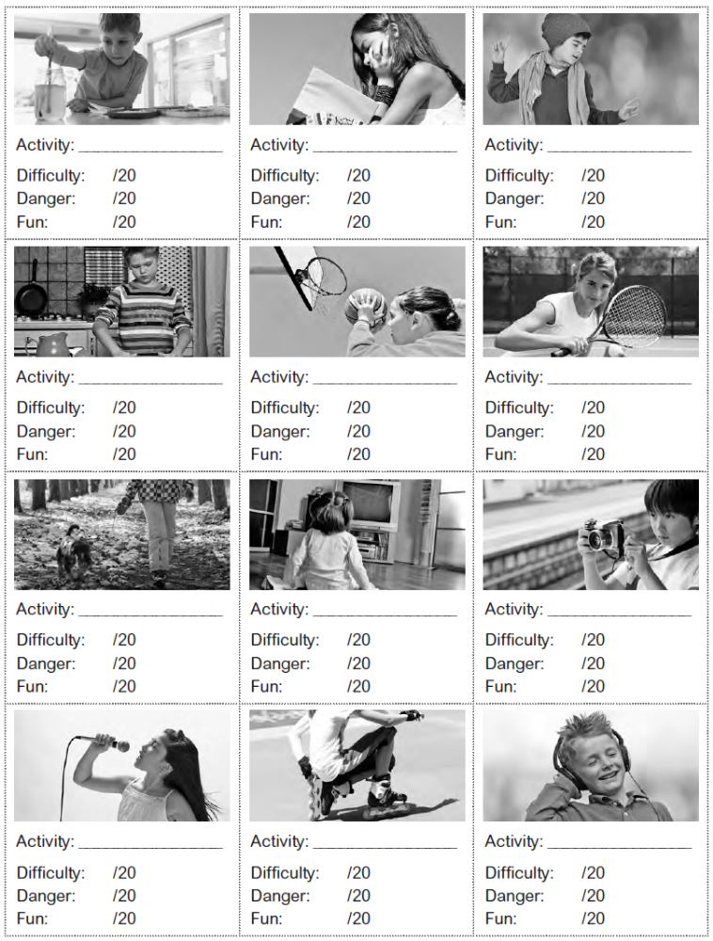

- Match the sentences.
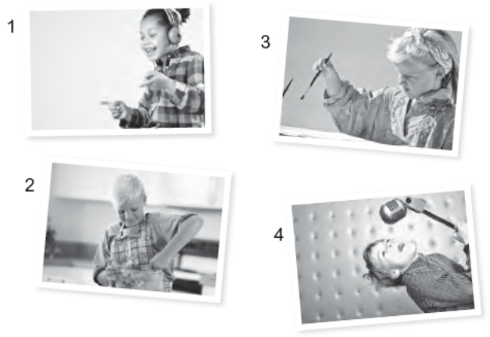
a She’s painting.
b She’s listening to music.
c He’s cooking.
d He’s singing a song.
- Write the actions.

1 He’s w____________ T___. 3 She’s w____________ t_____ d____.

She’s r____________ a b_______. 4 He’s t____________ p____________.
- Complete the sentences.
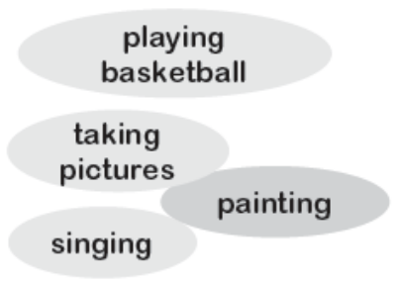
1 She’s _________ ___________ with her camera.
2 He’s ________________ with a paintbrush.
3 She’s ________________ a beautiful song.
4 He’s _____________ ____________ in the gym.
- Complete the sentences and match.
a She’s ______________.
b She’s ______________ to music.
c He’s _______________.
d He’s _______________ a song.
- Write the actions.
1 He’s ____________________. 3 She’s ____________________.
She’s ____________________. 4 He’s ____________________.
- Unscramble the words.
1 She’s itankg puesrict with her camera .
2 He’s ngintaip with a paintbrush.
3 She’s iinnggs a beautiful song.
4 He’s ngpylai basketball in the gym.
- Pre-listening Activity: Say what you like and don’t like.

- Listen and answer the questions.
1 What’s Mary doing?
She’s sitting at home reading a book.

2 Is Joe watching TV?
.
3 What time is Joe’s friend going to the park?
.
4 Is Mary playing football at three o’clock?
.
5 Who’s she playing tennis with?
.
- Listen again and complete.
1 Mary: _______________________?
2 Joe: Hi Mary. What are you __________________________?
3 Mary: I’m __________________________.
What are you doing, Joe?
4 Joe: I’m ______________________. Do you want to go to the park. My friend
Jack is going at half past two. We can _________________________!
Roleplays! Which one are you?

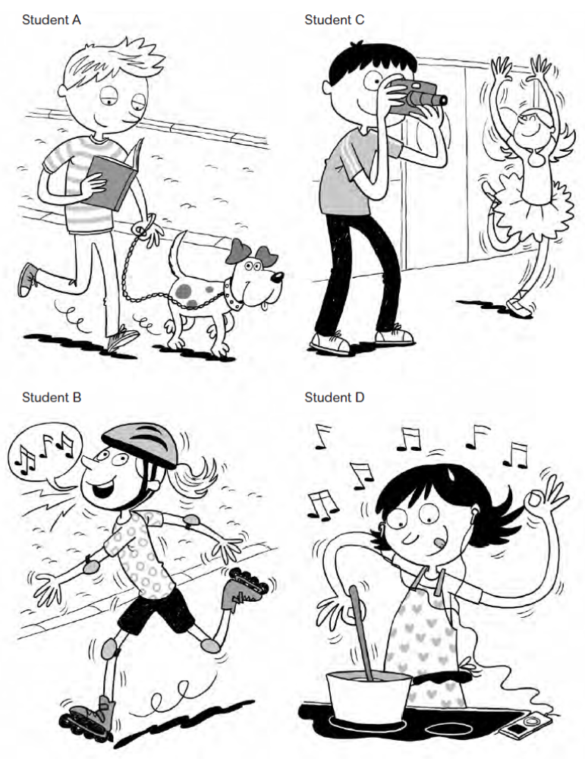
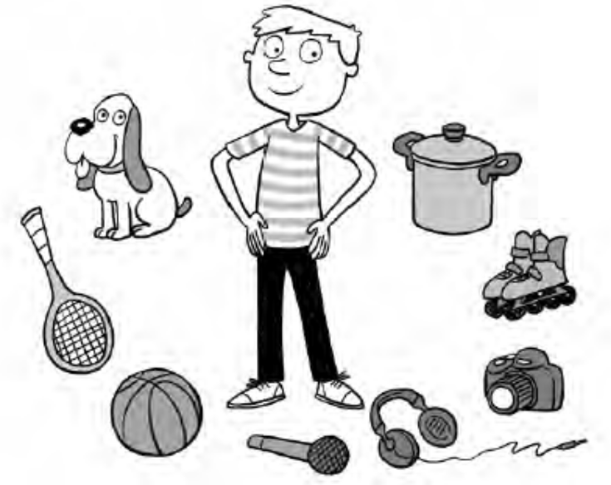
- Read and answer true or false.
Arnold is a busy boy! Today he’s getting up
at 7:00 and reading for two hours. Then
he’s playing tennis with Jake at 10:30
for three hours! At a 14:15 he’s cooking
with Jane and they’re having lunch
at a 15:15! At 16:30 Arnold has to walk
the dog and then he’s singing in the
choir before dinner at 19:30!
At night Arnold relaxes and listens to
music. Tonight he’s going to bed before
22:00 because tomorrow is a busy day too.
Tomorrow he’s playing basketball with Oscar!

1 Arnold is brushing his teeth at seven o’clock today.
2 At half past ten he’s playing tennis with Jake.
3 He’s having lunch with Jane at a quarter past three.
4 He’s skating at half past four.
5 Tomorrow he's playing basketball with Oscar.

- Read the text again and answer.
1 Is Arnold reading for two or for three hours?
reading for two hours.
He’s
2 Is he cooking or is he dancing with Jane?
He’s .
3 Is he walking the dog or the cat?
He’s .
4 Is he singing in the choir before or after dinner?
He’s .
5 What’s Arnold doing with Oscar tomorrow?
He’s .
- Read and answer true or false. Then correct the false sentences.
Arnold is a busy boy! Today he’s getting up at 7:00 and reading for two hours. Then he’s playing tennis with Jake at 10:30 for three hours! At a 14:15 he’s cooking with Jane and they’re having lunch at a 15:15! At 16:30 Arnold has to walk the dog and then he’s singing in the choir before dinner at 19:30!
At night Arnold relaxes and listens to music. Tonight he’s going to bed before
22:00 because tomorrow is a busy day too. Tomorrow he’s playing basketball with Oscar!

1 Arnold is brushing his teeth at seven o’clock today.

2 At half past ten he’s playing tennis with Jake.

3 He’s having lunch with Jane at a quarter past three.

4 He’s skating at half past four.

5 Tomorrow he's playing basketball with Oscar.

- Read the text again and answer.
1 Is Arnold reading for two or for three hours?
He's reading for two hours.

2 Is he cooking or is he dancing with Jane?
.
3 Is he walking the dog or the cat?
.
4 Is he singing in the choir before or after dinner?
.

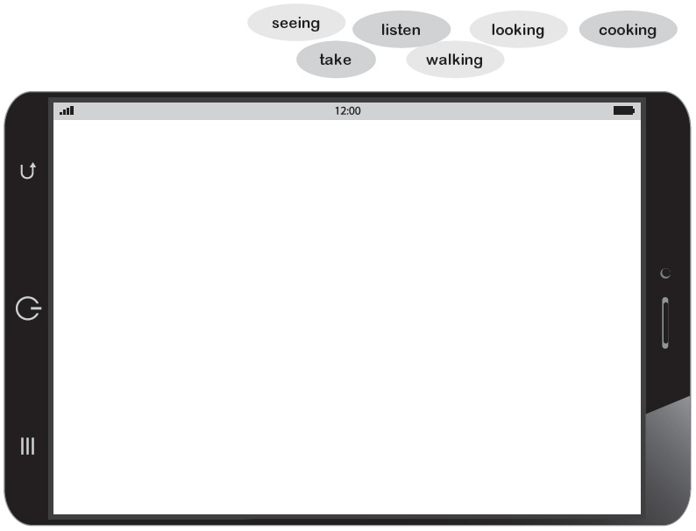
- Read and fill in the gaps.

Hi Louis!
Thank you for telling me about the birthday party today. I’m (1) ____________
at the calendar now and I can go! But first I have some things to do. At five
o’clock I’m (2) ___________________ my friend Annie and we’re
(3) _________________ the dog in the park. Then at a quarter past six we’re
(4) _______________ a meal to eat at a quarter past seven. But after that
I can go! We can (5)__________________ pictures,
(6) _________________ to music and have fun!
Thanks for inviting me, see you later!
Sue

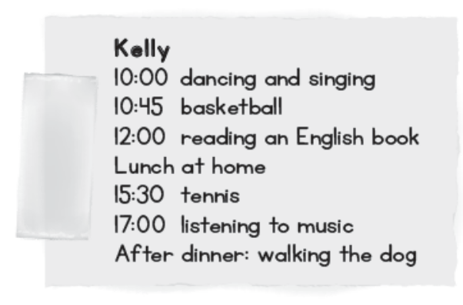
- Now write about what Kelly’s doing on Saturday.
At ten o’clock Kelly’s ____________________
___________ and at a quarter to eleven she’s
_______________________. In the afternoon,
she’s ________________________________.
Then she’s ____________________________
at half past three. At ___________________ she’s_______________________
and she’s __________________________________ after dinner.
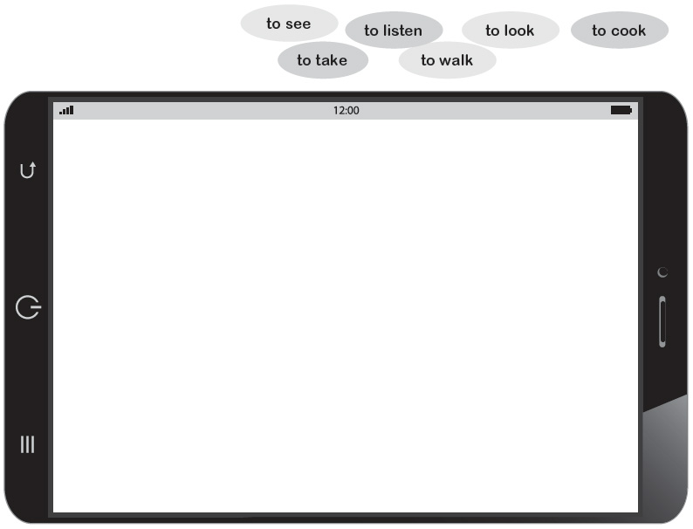
- Read and use the correct
form of the verbs to fill in
the gaps.

Hi Louis!
Thank you for telling me about the birthday party today. I’m (1) ____________
at the calendar now and I can go! But first I have some things to do. At five
o’clock I’m (2) ___________________ my friend Annie and we’re
(3) _________________ the dog in the park. Then at a quarter past six we’re
(4) _______________ a meal to eat at a quarter past seven. But after that
I can go! We can (5)__________________ pictures,
(6) _________________ to music and have fun!
Thanks for inviting me, see you later!
Sue

- Now write about what Kelly’s doing on Saturday.
At ten o’clock Kelly’s ____________________
___________ and at a quarter to eleven she’s
_______________________. In the afternoon,
she’s ________________________________.
Then she’s ____________________________
at half past three. At ___________________ she’s_______________________
and she’s __________________________________ after dinner.

